Master Briefing Summary
EVENT DATE
Wednesday 29th November

EVENT OVERVIEW / OBJECTIVES
An exclusive event which will be a platform to give selected advisers valuable face to face time with key directors/senior members of Scottish Widows, including CEO Chira Barua, along with subject matter experts from across Scottish Widows, LBG and the external financial world.

The theme of this years event is Collaboration for Tomorrow, highlighting that when we work together, we will deliver great results.

Event objectives include increasing market presence in the Mega and Trust space by engaging strategic advisers and showcasing thought leadership. The event will allow us to highlight the milestones and huge achievements Scottish Widows has reached in 2023, and ensure advisers feels valued and excited to be part of Scottish Widows moving into 2024.

AUDIENCE
Key strategic account managers with whom we have yet to unlock new business potential, or indeed those with an established book of clients who we would like to retain. Internal hosts should be strategic owners and key stakeholders from across RM, Props, MT etc.

CONTACTS
June Macfarlane  Ciara Twiggins | Events Team  Events Team | 07387 266 565  07741 291 616
Jill Henderson  Graeme Bold  Robert Cochran  Louise Whyte  Oliver Jones  Iain McGowan  Ranil Boteju  Pete Glancy  Andrew Warwick-Thomson  Matt Bailey  Chris Moore  Phil Allen  Sam Seaton | Scottish Widows Speaker / host  Scottish Widows Speaker  Scottish Widows Speaker / host  Scottish Widows Speaker  Lloyds Banking Group Speaker  Scottish Widows Speaker  Lloyds Banking Group Speaker  Scottish Widows Panel Speaker  SWMT Chair – panelist  Scottish Widows facilitator  The Pension Regulator – panelist  Scottish Widows Speaker  MoneyHub CEO – panelist | 07515 972 340  07385 024 117  07764 625 820  07384 901 549  0791 700 0647  07801 795 026  07384 244 602  07557 994 967  07875 886 586  07471 224934  07796 337 381  Via Phil Allen
Stephanie  Tom Mahon | Venue (Lumiere London)  AV supplier (London Filmed) | 020 7620 4570  07951 634 184

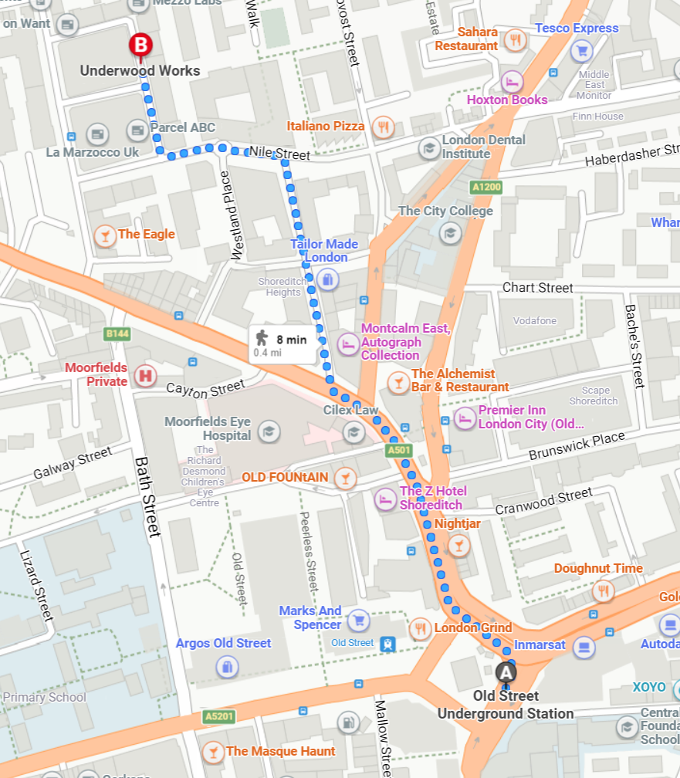
VENUE
Lumiere London  Underwood Works  6-14 Underwood Street  3rd Floor  Old Street London  N1 7JQ  (arrival through ‘The New White Loft’, 3rd floor)  Nearest tube  Old Street 5 minute walk or Barbican is a 15-20 minute walk | Rooms:  Plenary room – The Victorian Loft  Networking room – The White Loft  Additional space – The Chalet

EVENT AGENDA
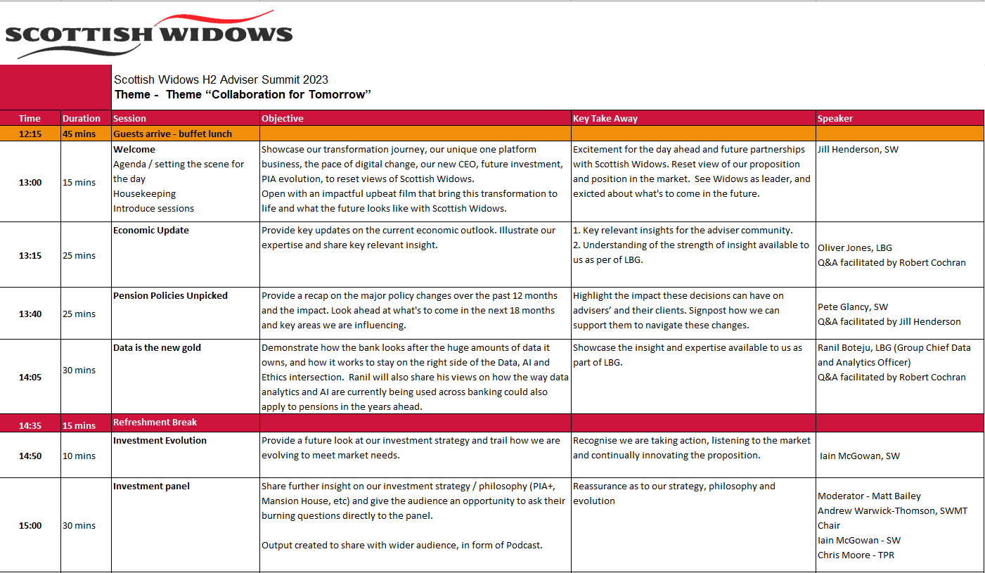
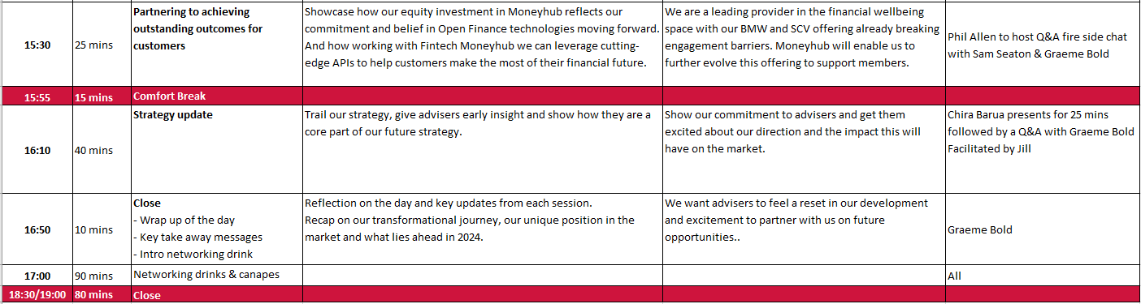

*please note, Andy Nicol has reserved a private area at the Alchemist – Old Street (145 City Road, Old Street, London, EC1V 1LP), should anyone, or your guests wish to continue your evening at 7pm.

GENERAL INFORMATION

ITEM | NOTES
DELEGATE NUMBERS | 33 SPEAKERS & HOSTS (Some speakers will not be in attendance for the full day)  50 GUESTS  83 total guests  As of 24th Nov
ACCESS TIMES | 29th November - Event Day  Access to room 08:00  Events Team on site for set up 08:00  AV team on site 08:00 (including stage set up), will be set up for 10:00  Scottish Widows speakers arrive for run through of content from 10:00 (if required)  Scottish Widows Hosts from 10:30-12  Guests arrive 12:15
REGISTRATION / NAME BADGES | Name badges will be given to all guests at registration.  3rd Floor ‘The White Loft’: Registration desk at entrance of white loft, cloakroom (rails) to the left corner of the room, behind reception desk.  Events team will be manning the registration desk.  In the instance that an attendee is not on the guest list, there will be spare name badges on the day so please write one.
VENUE SET UP | White Loft (reception area)  1 x table for badges/registration  1 x large SW Backdrop Banner  Occasional seating for guests  8 x poseur/occasional tables around the room for both lunch and drinks reception  Cloak room provided by venue – self service  Food and drink service area  Victorian Loft (plenary)  10 x 6ft tables  10 x white table cloths  7/8 x white chairs with cushions around each table – CABERAT SET UP  1 x lectern with laptop (SW to provide laptop)  4 x 85” TVs  1 x clicker  2x SW pull up banner  AV package (set up in back right corner of the room)  1 x AV technician  1 x HyperDeck studio HD mini  1 x Blackmagic micro converter  2 x 40m SDI cables  1 x audio engineer  1 x digital mixing desk  1 x Sennheiser G4 kit  2 x handheld mics  8 x lapel mics  1 x speaker system  1 x Antenna Distribution  3 x presenter laptops and cables  1 x 6x2m stage  1 x stage dress and set up  Sofa seating and tables
TO TAKE | 4 x boxes of name badges  Printed badges and spares  In black wheely bin (some merch is already at venue)  - 2 x pull up banners  - 1 x Backdrop banner  - 3 x iPad  - 2 x Remote clicker (back up)  - 2 x HDMI laptop adapter  - 70 x SW notepads  - 70 x SW pens  - 70 x SW chocolates  - 70 x feedback forms  June/Ciara to purchase AAA batteries
TO PRINT | - Name badges  - Reg list  - Briefing notes  - Filming disclaimers  - 1 page agenda
IPAD’s | iPad 1 – JH script and fireside chat questions (PA)  iPad 2 – timer for sessions  iPad 3 – Panel session questions (MB)
STAGE SET UP | Part 1  2 occasional seats, 1 table with glasses and jug of water, lectern on the right side, 2 x screens either side of stage and 2 screens at the side of each room, (lapel mics for speakers, hand held mics for guest participation).  Part 2  Investment panel – 4 occasional seats, 1 x lectern at the right side (to be removed after IMs session, 1 x table for water, 2 x screens either side of stage and 2 screens either side of room (lapel mics for speakers, hand held mics for guest participation)  Fireside chat – as above, with 3 seats  Part 3  3 occasional seats, 1 table with glasses and jug of water,1 x lectern at the side, 2 x screens either side of stage and 2 screens at the side of each room, (lapel mics for speakers, hand held mics for guest participation).  Events team will support with hand held mic’s for Q&A sessions.
MIC SET UP | Lapel number Part 1 Part 2 Part 3  Lapel 1 Jill Iain Chira  Lapel 2 Oliver Matt Graeme  Lapel 3 Robert Andrew Jill  Lapel 4 Pete Chris n/a  Lapel 5 Ranil Phil n/a  Lapel 6 n/a Sam n/a  Lapel 7 n/a Graeme n/a  Lapel 8 Backup Backup Backup  Ciara and June to have 2 handheld mics for audience
CATERING | The White Loft – main catering area  10:00 Tea/coffee and water to be available for 10 speakers/hosts  Confirmed Numbers for catering - 70  Water, tea/coffee/juice and biscuits – will be available all day  Lunch – Buddah Bowls  Mexican chicken and avocado  Rainbow salmon  Greek halloumi  Gourmet Baugette platters  Cake bites  Refreshment Break 1 (14:35)  Tea/coffee/juice and remaining cake bites  Refreshment Break 2 (15:55)  Tea/coffee/juice and petit fours  Drinks Reception  1 x 2 hour unlimited wine, beer and soft drinks, prosecco  Drinks  1 glass of prosecco on arrival  Les Lilas Blanc, Les Vignobles Foncalieu  Les Lilas Rouge, Les Vignobles Foncalieu  House beer selection (Peroni and Bud wiser)  Soft drinks  Canapes– waiting staff service included in package  3 hot and 3 cold canapes per person  Hot Canapes  Asian dim sum with honey soy dipping sauce (vegan)  Chicken satay with peanut sauce  Pank breadcrumb encrusted king prawn with wasabi aioli  Cold Canapes  Asparagus spear and sunblush tomato (vegan)  BBQ duck pancake with fresh ginger & cucumber  Hot smoked salmon and smoked salmon mousse in a charcoal cup with red keta caviar  The Victorian Loft  Water on tables to be replenished at break
DIETARY REQUIREMENTS | No dietary requirements advised
TABLE PLAN | There is no table plan for this event
FILMING and VOX POPS | Filming  We will be doing some filming of the event. The filimg will be done by Staurt Condy from SW.  The event will be sound recorded for theI Investment panel session to be used as a podcast post event, and we will also be filming the moneyhub and Chira session for internal purposes only. AV company London Filmed will be in charge of the sound recording and will share the raw file with Stuart Condy for editing post event.  We will also be creating a highlights film.  Vox pops  Jill, Graeme and Chira – to be filmed at the end of the closing session (reflection on the day)
POST EVENT MINUTES AND COMPLIANCE | Minutes  - Ernestina to capture the discussion minutes and send to Ciara/June  - Post Event Report to be completed by Ciara/June  - June/Ciara will submit to P&I Sales Compliance  Compliance  Our key responsibilities in agreement with Compliance is that:  - Events team monitor consumption of alcohol and liaise with waiting staff to restrict, if necessary  - Events team to check people in so only invitees in attendance  - Confidential waste to be removed from the venue  Information on Lloyds Banking Group’s position can be found on the local Lloyds intranet.  Post Event Comms  - A thank you email will be issue to all attendees post event with a link to the feedback form  - A highlights film and PDF write up of the event will be shared on the Adviser LinkedIn channel post event, and the workplace insights webpage.  - Social post will also be done for the panel podcast.
SIGNAGE | Guests will enter via the main entrance and will be directed to registration area in the White Room.  No Scottish Widows or Lloyds Banking Group signage to appear in any public areas at the venue.
ACCOMMODATION/TRAVEL | Attendees/hosts to arrange their own travel & accommodation for event if required.
DRESS CODE | Business Casual
HEALTH AND SAFETY | Fire alarm tests: No fire alarms scheduled for this date.  Fire exits: Fire exits are clearly marked with green signage for exits.  Emergency Procedures: Guests to make their way to the nearest emergency exit, avoiding the use of lifts and following venue staff
BILLING | Outstanding Invoices will be settled post event by Ciara/June.
KEY HOST DUTIES | SW hosts to look out for their guests arriving and help with coats/bags. It is not a ticketed cloakroom so they may want to keep their belongings with them.  Please direct guests to reception desk and help find their names badge and confirm with the events team who has arrived.  Once registered please use this time for networking and a relaxed lunch.  Please do not all queue at once, or block the queue and ensure you are spread out across the White Loft (guests may put their personal belongings in the Victorian Loft at the table if they wish).  Make Advisers aware that we will be creating a highlights reel which will be used to promote future events and on LinkedIn. They may appear in passing or networking footage, so if they have an issue with this then please report it to the registration desk.  We are keen to amplify this event on the day, so do share any photos or insights on LinkedIn  or repost items that your colleagues have shared about the day.
SPEAKER INIFO | All final slides (where applicable) should be Ciara June by 5pm on Monday 27th November in 16:9 widescreen format.  If you have a video you wish to use, please supply the MP4 for this as we don’t like to trust links if the wifi isn’t great.  Please arrive at the venue from 10:00 and you can have a click through of slides on the stage etc until 11:45. You will be fitted with a lapel microphone before we kick off at 13:00 or over the break if your session is later.  If you are not able, or do not need to arrive early for a run through, please ensure you arrive at least 15 minutes ahead of your session.  Key points to be covered by Jill during the welcome:  - Fire exits (no planned fire alarm tests)  - Mobile phone on silent  - Toilets  - Questions for speakers – questions will be taken live from the floor  Key points to be covered at the end:  - Thank you for joining us  - Networking drinks and canapes will be served in the white loft (catering room)  - Feedback – let us know what you think using the feedback forms on your table.
MISCELLANEOUS | - Feedback – A feedback form will be put on each guests seat. Post event, guests will be invited to fill our a more in depth feedback form which will include feedback on each of the sessions.

ROLES AND RESPONSIBILITIES

CIARA | Venue & AV Lead  08:00  - Ensure all packages/equipment etc has arrived  - Set up White Loft including cloakroom and registration desk  - Set up Victorian loft (correct seat numbers, occasional seating etc)  - Ensure screens are all placed correctly  - Set up any banners across the 3 rooms (if/where needed)  09:00 Speakers arriving  - Ensure tea/coffee set up for speakers arriving  - Layout all badges on registration desk ready for signing in  - When speakers arrive tick off their name on the reg list and give them their badge. Show them around the space to familiarise themselves  - Check with Stuart about filming set up and London filmed on recording  10:00  - Ensure all mics are working  - Practise playing welcome video prepped  - Confirm layout of lunch being served and ensure no congestion issues  - Confirm any final number amends or dietaries with venue  - Have additional stage chairs in an easily accessible position  - Set up stage setting for 1st half of the day  11:00  - Complete final set up  - Ensure water on tables and stage are fresh and the main room tea and coffee station is set up  - Explain that hosts can support guests with jackets and bags etc and if registration becomes busy then hosts may need to help out. They can just take a badge for their client and we’ll tick them off the list later based on what badges are no longer on the table  - At 12:15 ensure hosts are in position (i.e. at the venue reception etc)  12.15 Guests arrive / lunch served  - When guests arrive tick off their name on the reg list and give them their badge. Their hosts should be waiting to welcome them, help with coats, get them a coffee and lunch  - Ensure lunch is topped up as and when required  12.50  - Move guests through to The Victorian Loft (leave spaces next to doors for latecomers)  - Holding slide on TV’s  14:00  - Prep for refreshment break  14:35 Refreshment break  - Once guests are out of the Victorian loft, set up the stage for the panel session 14:50, mic panellists up with lapel mics and do a quick sound check  - Encourage guests back to seats for sessions recommencing  15:30  - Be on hand to remove additional panel chair and re-set stage for 3 speakers  17:00 Drinks reception  - Man registration desk for people leaving: request they return their badge and scan the feedback QR to complete on their way out.  19.15 Pack up
JUNE | Content Lead  08:00  - Ensure final content is ready for sharing on laptop  - Support with room set up where needed  - Have timer ipad ready  - Ensure guest seating is spaced out correctly  - Familiarise with building – where are toilets, where could someone take a call (potentially in lounge space on another floor)  09:00  - Start speaker run through and ensure speakers are all happy with their slides & videos,  - Practise using clicker with speakers  - Introduce speakers to AV team where appropriate (Robert and Stuart)  - Source ipad for timing of sessions  10:00/11:00  - Check panellists are all happy with rehearsal and on screen content  - Prep speakers with mics etc  - Ensure happy with final set up  12:15 Guest arrival  - Support Ciara with registration: When guests arrive tick off their name on the reg list and give them their badge. Their hosts should be waiting to welcome them, help with coats, get them a coffee and lunch  - Direct any late arriving speakers to Victorian loft to familiarise themselves and ensure happy with layout and slides.  12.50  - Move guests through to The Victorian Loft (leave spaces next to doors for latecomers  - 10 min timer set up on ipad for welcome session  13:10  - Prep OJ ahead of going on stage  - 25 min timer on ipad for Economic session  13:35  - Prep PG ahead of going on stage  - 25 min timer on ipad for Pensions Policy Unpicked  14:00  - Prep RB ahead of going on stage  - 20 min timer on ipad for data is the new gold  14:05  - Support with prep for refreshment break  14:35 Refreshment break  - Encourage guests back to seats for sessions recommencing at 2:50  - Prep IM ahead of going on stage  - 10 min timer on iPad for investment evolution  15:50  - Ensure panellists are ready and mic’d up for investment podcast  - 30 min timer on ipad for investment panel  15:25  - Prep SS, GB and PA ahead of going on stage  - Set 2 min timer on ipad for Moneyhub session  15:55 Refreshment break  - Meet CB arriving and set up for going on stage  - 25 min timer on iPad for strategy update. Once this has finished and GB has joined the stage, a 25 minute timer is to be set for Q&A  16:50  - Set 1 min timer for closing session  17:00 Drinks reception  - Man registration desk for people leaving: request they return their badge and scan the feedback QR to complete on their way out.  19.15pm Pack up

GUEST LIST

First name | Surname | Company
David | O'Reilly | Johnson Fleming
Steve | Etherington | PwC
Roshni | Patel | PwC
Mike | Ambery | Hymans Robertson
Claire | Roarty | Hymans Robertson
Hannah | English | Hymans Robertson
David | Croker | MMB
Marcus | Bambury | MMB
Nicky | Barker | MMB
David | Bouchard | MMB
Julie | O'Donnell | MMB
Christian | MacLeod | MMB
Mark | Pemberthy | Gallagher/Buck
Alan | Morahan | PSA
Jason | Cannon | AJG
Tom | Jarvis | AJG
Steve | Threader | AJG
Lydia | Fearn | LCP
Laura | Karam | LCP
Nigel | Dunn | LCP
Andrew | Barradell | Benefex
Simon | Pascoe | Benefex
Debbie | New | Lockton
Rosalind | Smillie | Lockton
James | Slater | Benefex
Richard | Haynes | PIB
Mark | Scott | Benefex
Lee | French | First Act
Andreas | Hunter | Buck/Gallagher
Chris | McWilliam | Aon
Warren | Williamson | Capita
Martin | Parish | Aon
Nicky | Clynes | Barnett Waddingham
James | Eaglesham | Aon
Mike | Varma | Aon
Alex | Tony | Barnett Waddingham
Tom | Chalkley | Isio
Alex | Gristwood | Isio
William | Johnson | INK
Paul | Conroy | Aon
Andy | Parker | Barnett Waddingham
David | Farmer | IGG
Alison | Charman | Aon
Michael | Robinson | Kingswood group
James | Staley | Aon
Mike | Denton | TISCO
Ben | Smith | TISCO
Hannah | Lewis | Behave London
Jason | Lines | HFMC
Mark | Futcher | Barnett Waddingham

*names highlighted are those who have been put forward to be introduced to Chira.

SPEAKERS AND HOSTS

Host/Speaker | First name | Surname
Host | Graeme | Bold
Speaker | Jill | Henderson
Speaker | Robert | Cochran
Host | Lucy | Blanchard-Burton
Host | Simon | Wright
Host | Louise | Whyte
Host | Sharon | Bellingham
Host | Ali | Nicolson
Speaker | Peter | Glancy
Host | Jane | Clark-Hutchison
Host | Ernestina | Saarrah-Mensah
Events | June | Macfarlane
Events | Ciara | Twiggins
Host | Karen | Boyle
Host | Ben | Millar
Host | Abbi | Carter
Host | Richard | Thorkildsen
Host / speaker | Matt | Bailey
Host | Paul | Robertson
Speaker | Oliver | Jones
Speaker | Ranil | Boteju
Speaker | Andrew | Warwick-Thomson
Speaker | Iain | McGowan
Speaker | Chris | Moore
Speaker | Phil | Allen
Speaker | Sam | Seaton
Marketing | Paul | Rutowski
Marketing | Laura | Tervit
Marketing | Sally-Louise | Meikle
Host | Chris | White (TBC)
Host | Scott | Brooks
Host | Adam | Paterson
Host | Janine | Tumilowicz

